PayDollar/PesoPay/SiamPay PayGate
Integration Guide for Drupal Commerce (Kickstart 2.x) 7.x

Outline
- Currency setup
- Install the module on Drupal Commerce
- Module configuration
- Setup datafeed URL on PayDollar/PesoPay/SiamPay

Note: This guide assumes that Drupal Commerce 7.x (KickStart 2.x) is already installed on your web server. Actual screenshot may varry on this document compared with the actual screens installed on your site.

Currency Setup

This plug-in currently cannot support multi-currency feature. Therefore you need to set the default currency be the same as the enabled currency and should only enable one currency. (Must be the same currency as your PayDollar/PesoPay/SiamPay merchant account)

1. After login, Go to Store > Configuration > Currency Settings. In this example, we use PHP as the default currency and we also enabled PHP on the 'Enabled currencies'. After setting up, click the 'Save Configuration' button
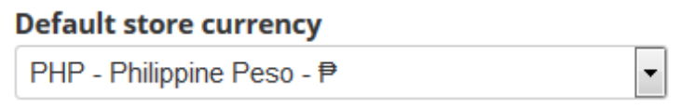

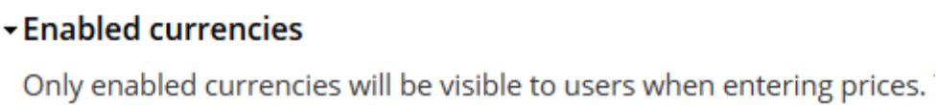

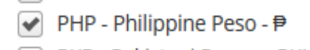

Install the module on Drupal Commerce

1. Go to Modules the click 'Install new module'. Browse the module and click the 'Install' button
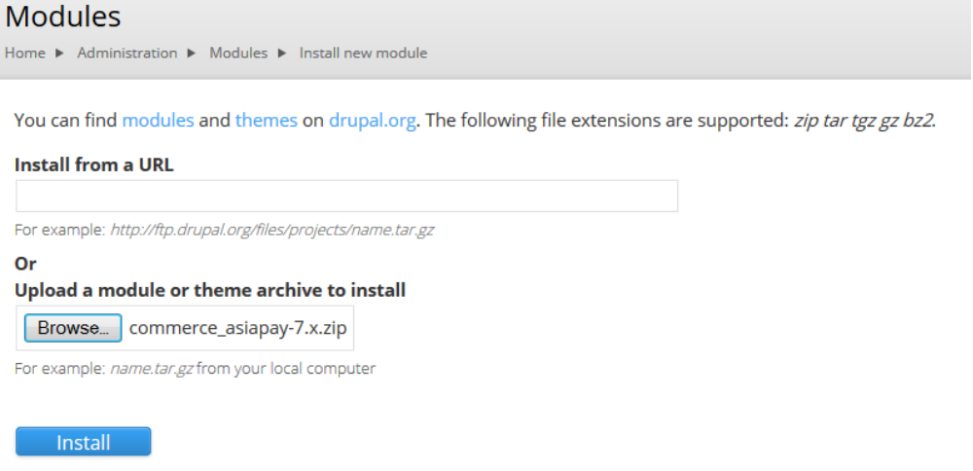

2. After successful installation, click the 'Enable newly added modules' to go to the module listings page
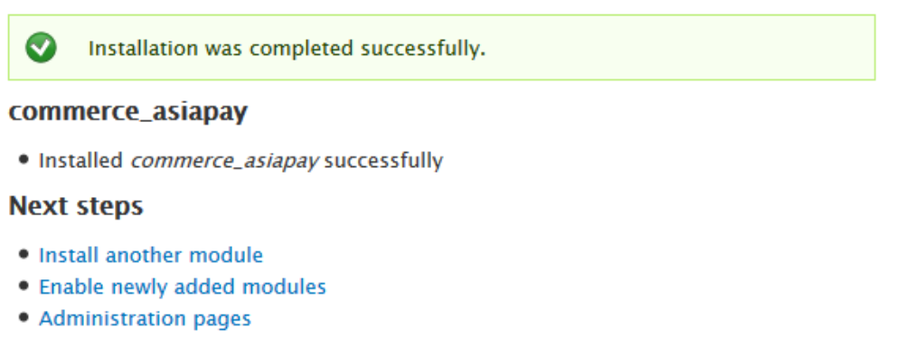
3. Search for 'Commerce AsiaPay' module and enable it then click 'Save Configuration' on the left sidebar.
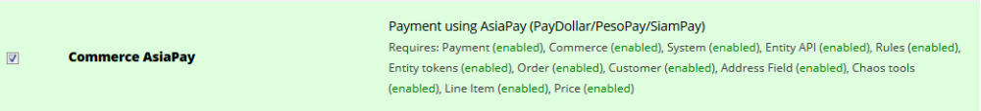

Module Configuration

1. Go to Store > Configuration > Payment Methods. Look for 'AsiaPay' and click 'enable'
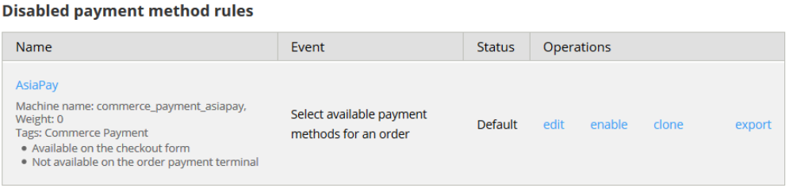

2. Once enabled, click 'edit'
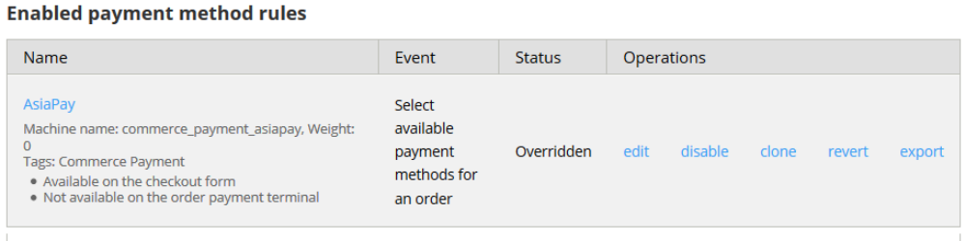
3. Find AsiaPay on the 'Actions section' and click 'edit'
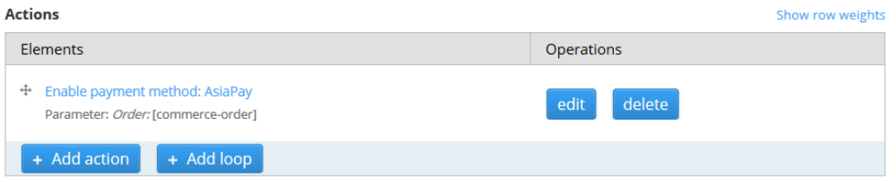

4. Setup the AsiaPay module correctly and click the 'Save' button.
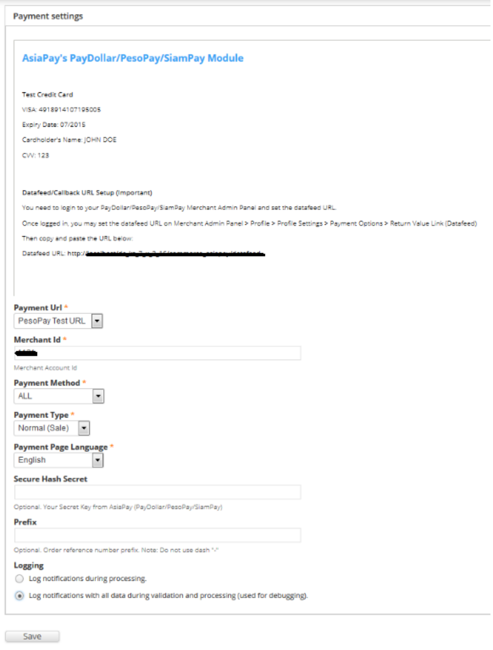

Payment URL: The integration URL to which platform you are to integrate.
Merchant Id: The merchant account id provided by PayDollar/PesoPay/SiamPay
Payment Method: The payment method to display on the payment page.
Payment Type: Set either Normal or Hold (Depends on your PayDollar/PesoPay/SiamPay)
Payment Page Language: Set the payment page language.
Secure Hash Secret: Optional. Your Secret Key from AsiaPay (PayDollar/PesoPay/SiamPay)
Prefix: Optional. Order reference number prefix. Note: Do not use dash "-"
Transaction Type: Optional. Suitable transaction type. Goods/ Service Purchase is the Default value if transaction type not provided.
Challenge Preference: Optional. Indicates whether a challenge is requested for the transactions in 3DS2.0. * If “No challenge requested” options are selected, the chargeback liability shift to merchant.

Note: Read carefully the module description on the top portion especially on the 'Datafeed/Callback URL Setup (Important)' section as its the needed on the next step.

Setup the Datafeed URL on PayDollar/PesoPay/SiamPay

1. Login to your PayDollar/PesoPay/SiamPay account.
- PayDollar
  - Live: https://www.paydollar.com/b2c2/eng/merchant/index.jsp
  - Test: https://test.paydollar.com/b2cDemo/eng/merchant/index.jsp
- PesoPay
  - Live: https://www.pesopay.com/b2c2/eng/merchant/index.jsp
  - Test: https://test.pesopay.com/b2cDemo/eng/merchant/index.jsp
- SiamPay
  - Live: https://www.siampay.com/b2c2/eng/merchant/index.jsp
  - Test: https://test.siampay.com/b2cDemo/eng/merchant/index.jsp

2. After login, Go to left sidebar on Profile > Profile Settings > Payment Options.
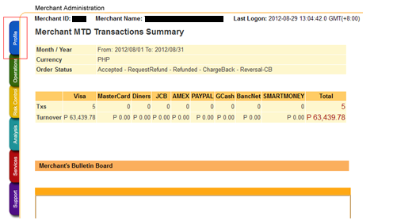

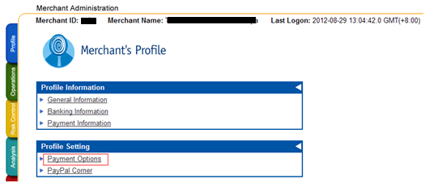
3. Click the “Enable” radio and set the datafeed URL on “Return Value Link” and click the “Update” button.
The datafeed URL normally looks like this: http://www.yourdrupalcommercesite.com/commerce_asiapay/datafeed
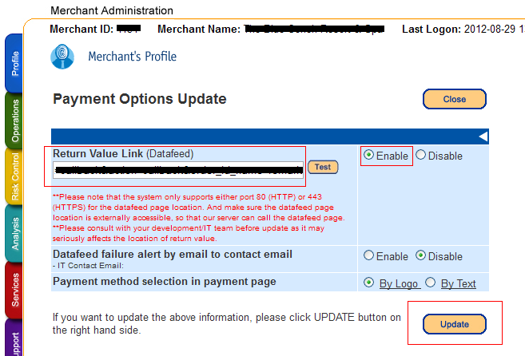

4. On the confirmation page, review your changes then click the “Confirm button”.
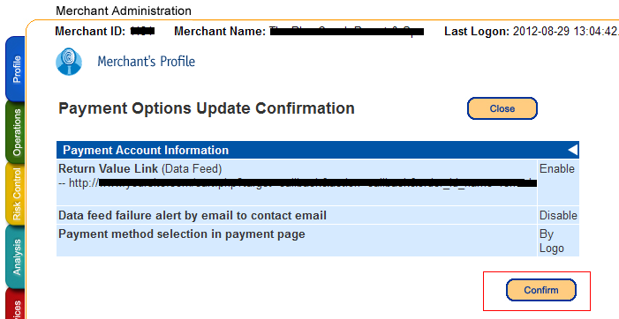

5. The datafeed URL has been set.
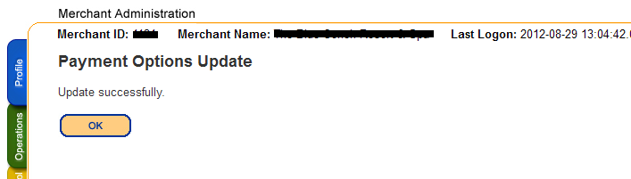

The End

